Austin Smothers

CISP 310

Assignment 7

; Max3.asm, a program which finds the maximum
; between three numbers
; Austin Smothers
; CISP 310
; November 26, 2017

.586
.MODEL FLAT

INCLUDE io.h

.STACK 4096

.DATA
numLrgFin DWORD 11 DUP (?), 0
promptNum BYTE "Enter A Number", 0
string DWORD 40 DUP (?)
resultLbl1 BYTE "Sum of Numbers: ", 0

.CODE
_MainProc PROC

call numAddr ; call the numAddr procedure

output resultLbl1, numLrgFin ; output numLrgFin

mov eax, 0 ; reset eax
mov ecx, 0 ; reset ecx

ret
_MainProc ENDP

; a procedure to accept 3 user input numbers and add them
numAddr PROC
mov eax, 0 ; reset eax for addition
mov ebx, 0 ; reset ebx for addition
mov ecx, 0 ; reset ecx for loop

getAdd: cmp ecx, 3
jge endgetAdd ; if ecx >= 3, jump out
input promptNum, string, 40 ; ask for user input
atod string ; convert string to a decimal, put in eax
add ebx, eax ; add the input number to ebx
inc ecx ; increment ecx
jmp getAdd ; do it again
endgetAdd:

dtoa numLrgFin, ebx ; convert numLrgFin to ASCII store in eax

ret

numAddr ENDP
END ; end of source code
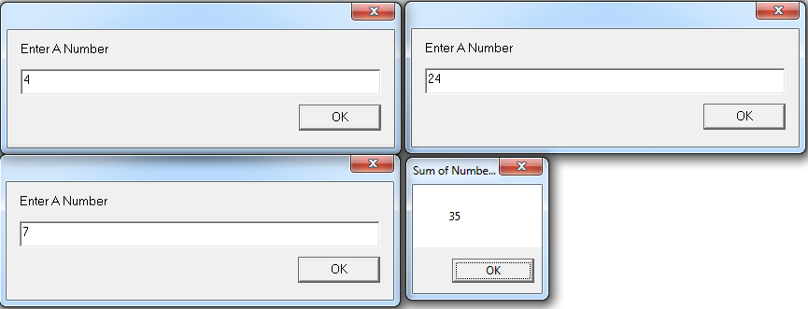
; PosNeg.asm, a program which finds if
; a number is positive, zero, or negative
; Austin Smothers
; CISP 310
; November 27, 2017

.586
.MODEL FLAT

INCLUDE io.h

.STACK 4096

.DATA
num1 DWORD 11 DUP (?), 0
promptNum BYTE "Enter a Number", 0
string DWORD 40 DUP (?)
resultLbl BYTE "The Number is", 0
resultNeg BYTE "Negative", 0
resultPos BYTE "Positive", 0
resultZero BYTE "Zero", 0

.CODE
_MainProc PROC

call posNeg ; call the PosNeg function
mov eax, 0 ; reset eax
ret
_MainProc ENDP

; a procedure to check if a number is positive or negative
posNeg PROC

input promptNum, string, 40 ; read ASCII characters
atod string ; convert string to decimal
mov num1, eax ; put eax in num1

cmp num1, 0 ; compare eax to 0

jz zeroNumber ; jump if the number is zero
jg posNumber ; number isn't zero, jump if positive
jmp negNumber ; number must be neg

zeroNumber: output resultLbl, resultZero ; result is zero
jmp exit

posNumber: output resultLbl, resultPos ; result is positive
jmp exit

negNumber: output resultLbl, resultNeg ; result is negative

exit:

ret

posNeg ENDP
END ; end of source code
